Operating instructions

- Open the software
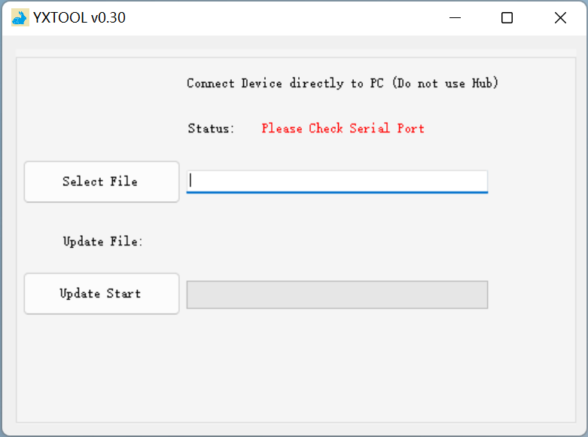
- Waiting for connection
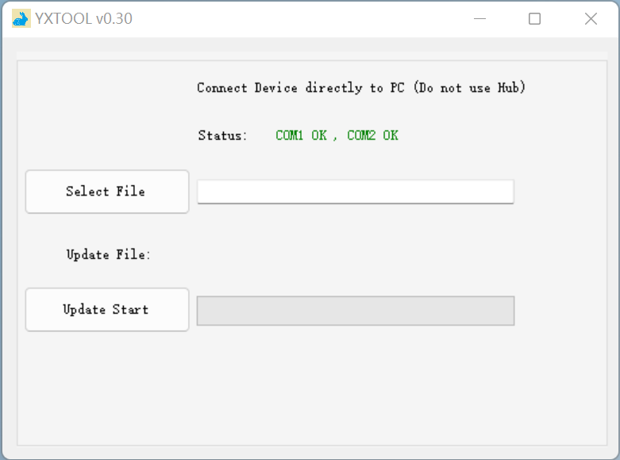
- Select mix file
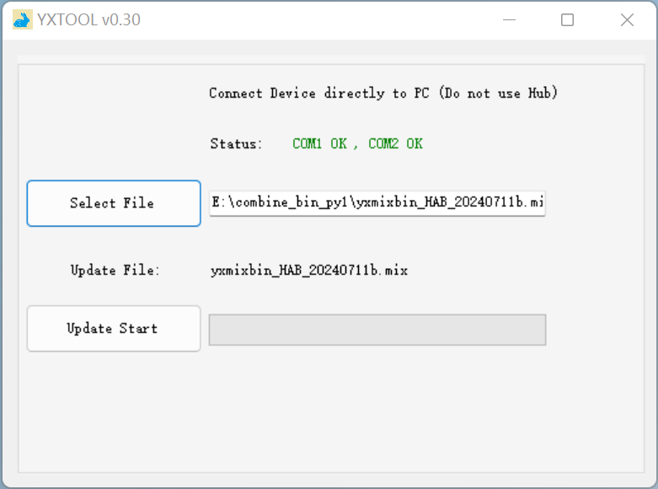
- Check the file name and download
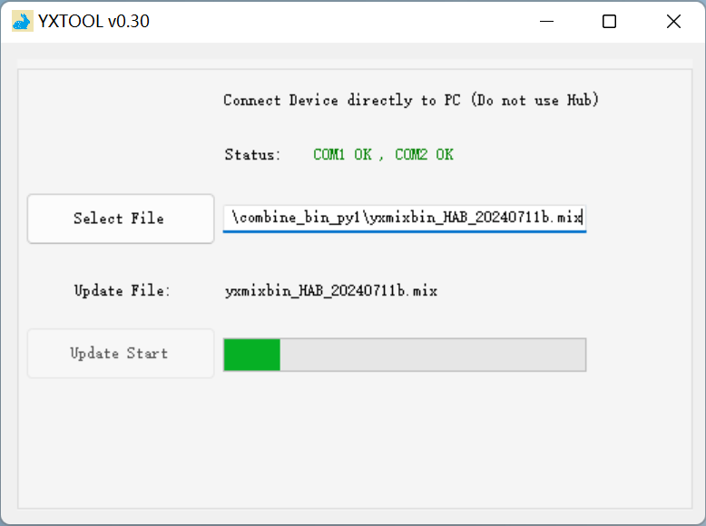
- Download completed
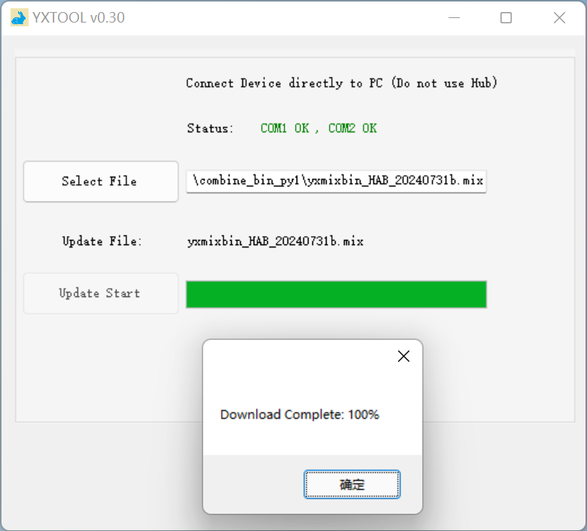
Note：If the device disconnects during the download process and the download is interrupted, please reconnect the device after the countdown ends, wait for the serial port to connect and download.
